Geometry: Unit 5, Lesson 8
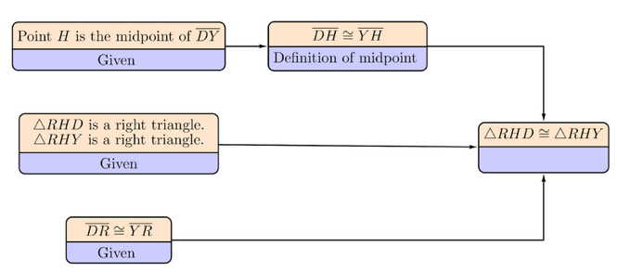
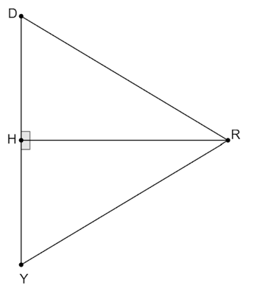
- Right triangles $RHD$ and $RHY$ are shown. Given: $RHD$ is a right triangle. $RHY$ is a right triangle. $\overline{DR}≅\overline{YR}$. Point $H$ is the midpoint of $\overline{DY}$. An incomplete flowchart proof is shown. What is the reason for $∆RHD≅∆RHY$?

AAS
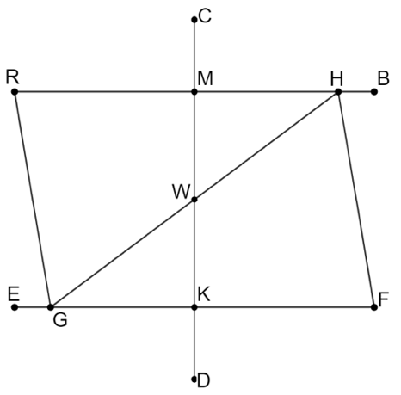

- In the diagram, $\overline{RB}$ is parallel to $\overline{EF}$ and $\overline{RG}$ is parallel to $\overline{HF}$. Given that $\overline{RB}$ is parallel to $\overline{EF}$, then what can be concluded?

$$∠RHG≅∠FGH$$
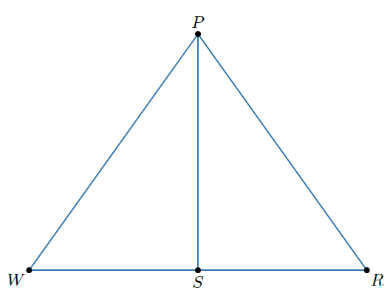
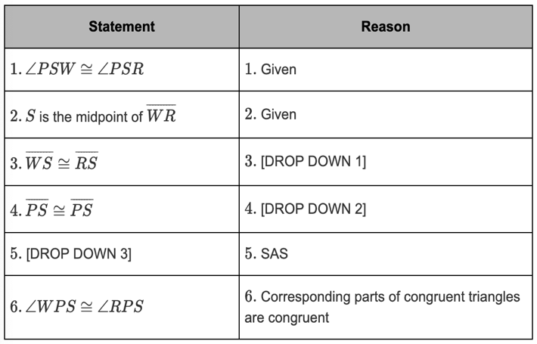
- Triangle $PWR$ is shown. Given: $∠PSW≅∠PSR$, point $S$ is the midpoint of $\overline{WR}$. Prove: $∠WPS≅∠RPS$. A partial two column proof is shown in the table. Complete the proof for statement 3.

Definition of midpoint

